Dennisse Campos
11/24/25
CIS345
Lab 3

- Threshold Configuration
  - Threshold for disk, memory, and log retention are defined at the top of the script, making them easy to modify
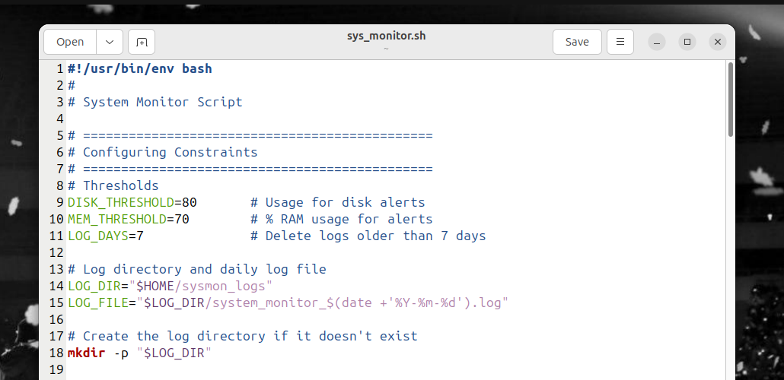

- Command-line Options
  - The script supports:
    - ‘-v’ or ‘--verbose’ : Prints full system reports
    - ‘-q’ or ‘--quiet’ : Suppresses terminal output
  - These modes enable flexible usage for automated or manual monitoring
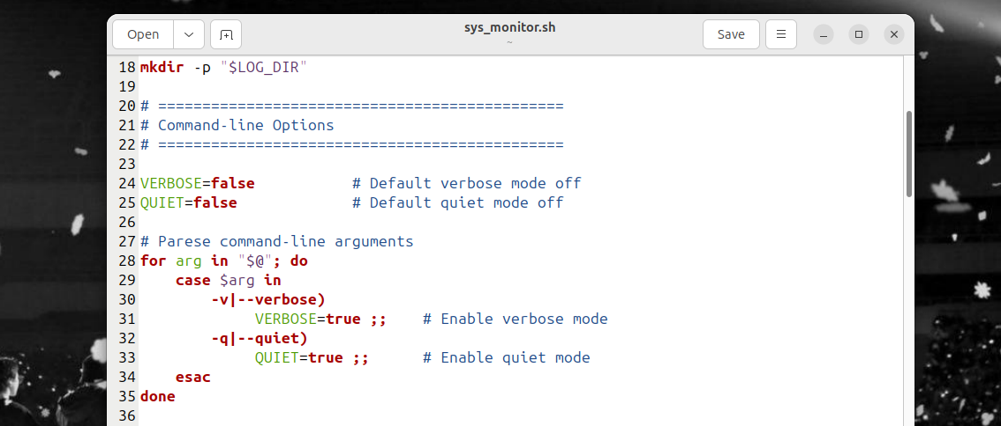
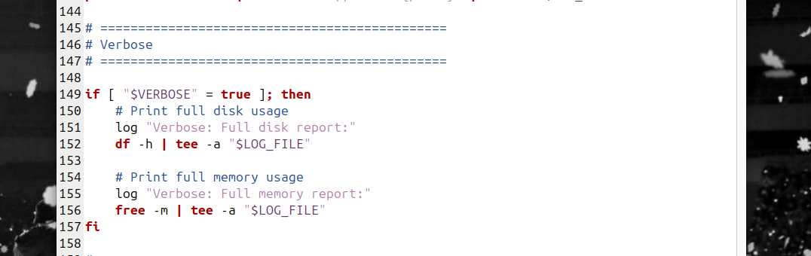
  - I added the verbose code at the bottom of the file

- Logging system
  - The ‘log()’ function prints timestamps and writes all content to a daily log file. Quiet mode disables terminal output but keeps logging enabled.
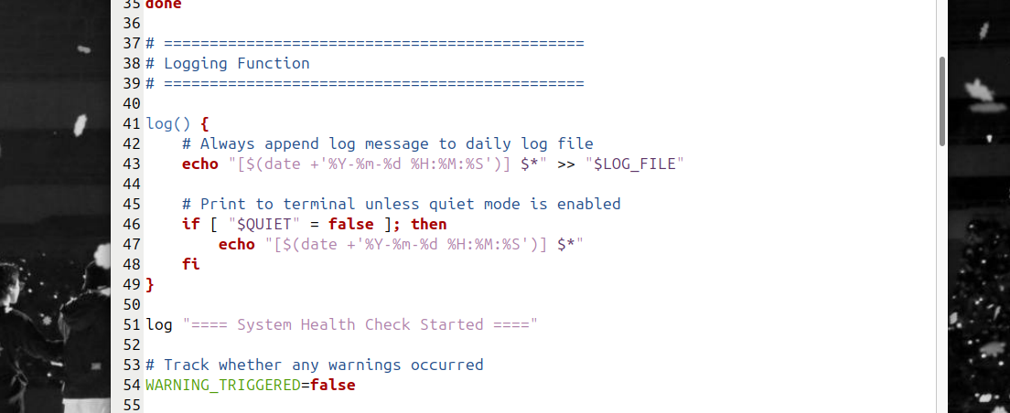
- Disk Usage
  - Disk usage is collected using:
    - df -h / | awk ‘NR==2{print $5}’
  - The percentage is compared with the defined threshold
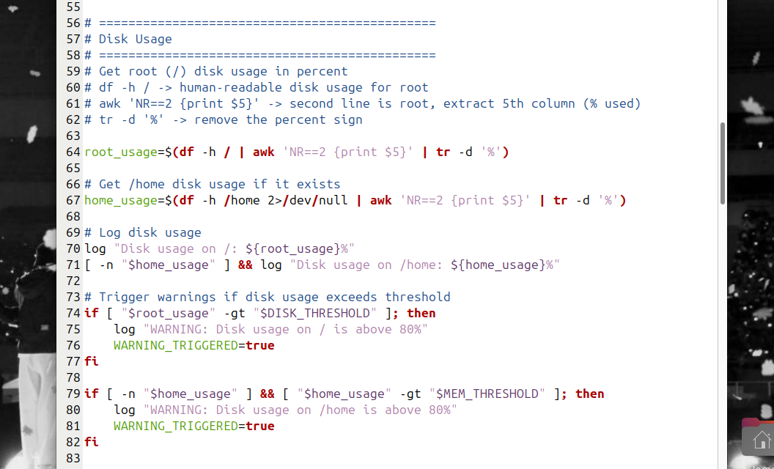

- Memory Usage
  - The script uses:
    - free -m – to extract total and used memory.
  - Percent usage is computed and compared against a threshold
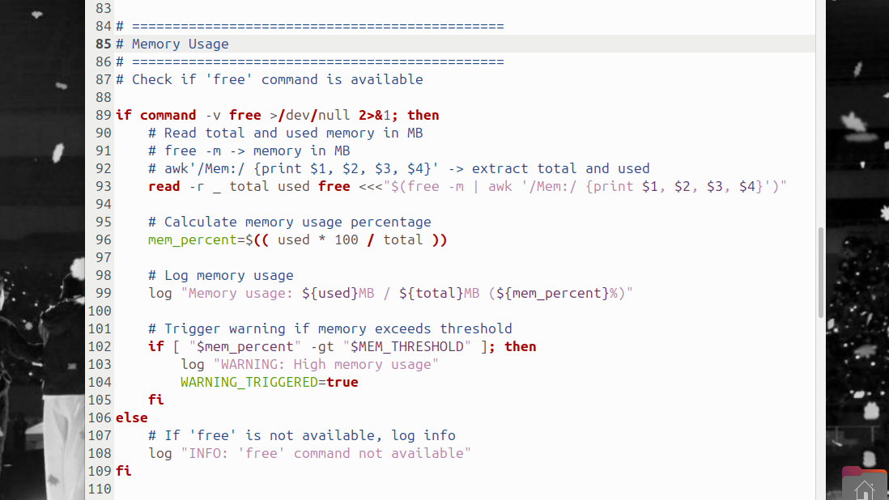
- Load Average
  - CPU load (1-minute average) is taken from ‘/proc/loadavg’. The load is compared to the total number of CPU cores from ‘nproc’
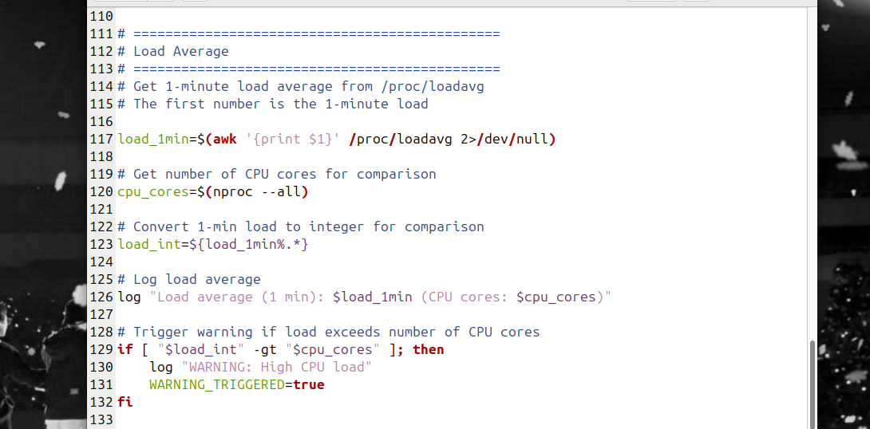
- Top 3 Processes
  - The script gathers the top 3 memory-consuming processes using:
    - Ps aux –sort=-%mem | head
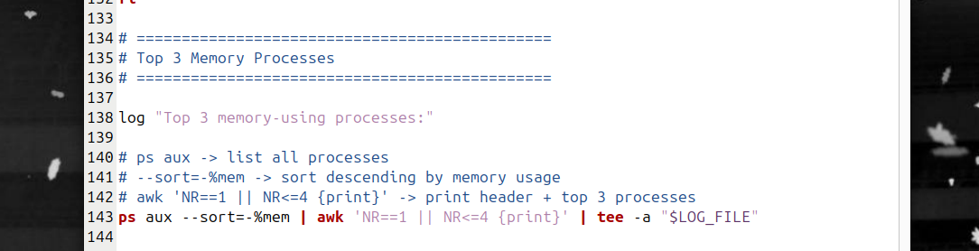
- Log Rotation
  - Logs older than 7 days are removed automatically with:
    - Find “$LOG_DIR” -type f -name “*.log” -mtime +$LOG_DAYS -exec rm{} \;
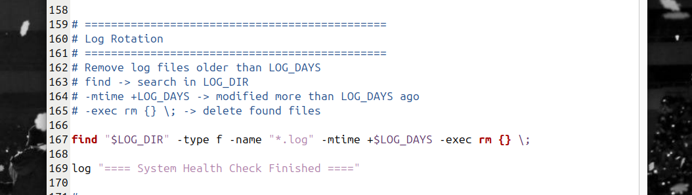
- Exit Codes
  - Exit Code 0: Indicates a Healthy Run. No thresholds were exceeded, and the script finished successfully.
  - Exit Code 1: Indicates an Alert/Warning. This is triggered if disk usage, memory, or CPU load exceeds the predefined thresholds.

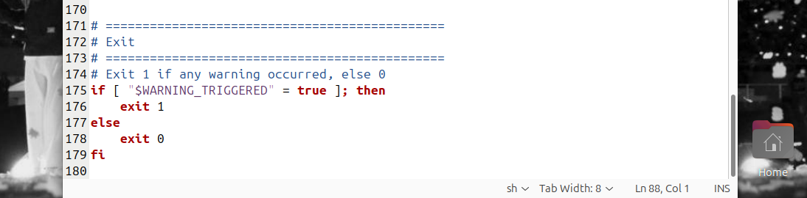

- Result
  - ./sys_monitor.sh
    - 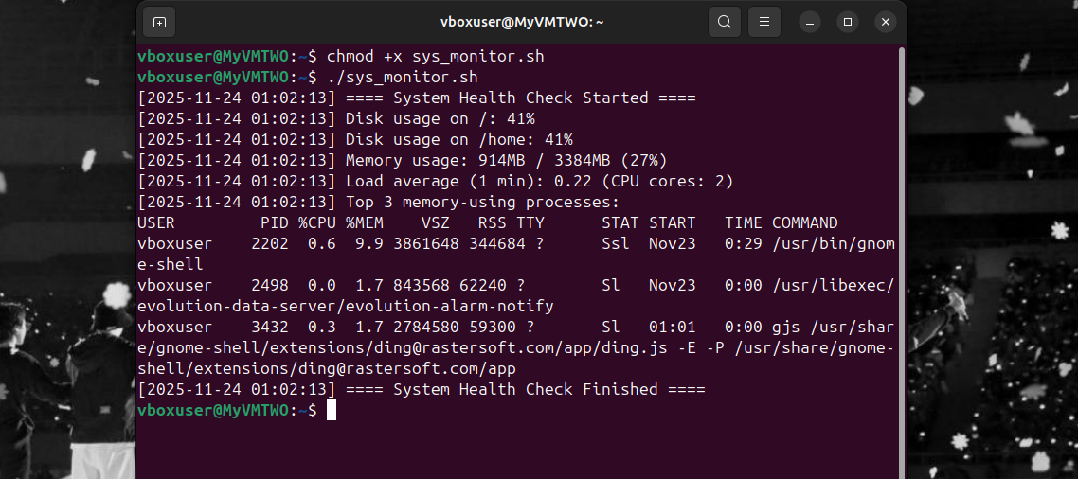
  - ./sys_monitor.sh --verbose
    - 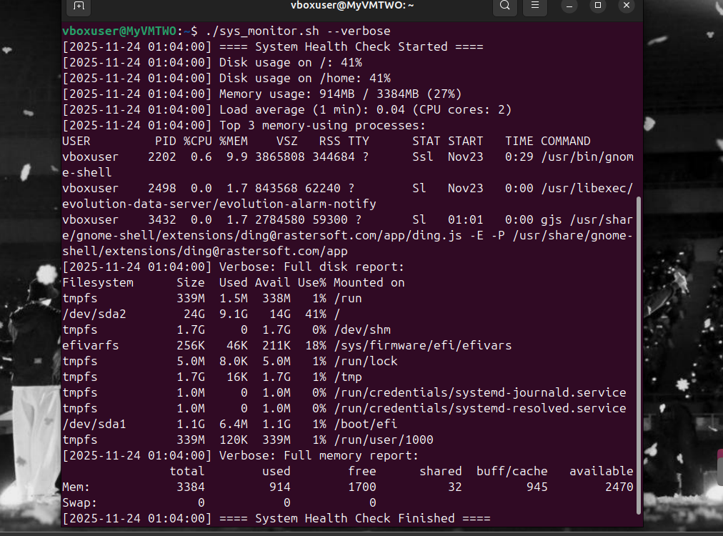

  - ./sys_monitor.sh --quiet
    - 